**Project Design Phase Solution Architecture**

|  |  |
| --- | --- |
| Date | 26 June 2025 |
| Team ID | LTVIP2025TMID20380. |
| Project Name | HouseHunt: Finding Your Perfect Rent  al Home |
| Maximum Marks | 4 Marks |

**Solution Architecture – HouseHunt**

HouseHunt follows a modern web-based architecture using the MERN stack (MongoDB, Express, React, Node.js). It ensures a scalable, secure, and real-time rental listing experience through a modular, API-driven design.

**Goals of the Architecture:**

* Ensure scalability as user base grows
* Provide fast and secure data access
* Maintain modular design for easy updates
* Enable real-time communication (chat/call)
* Ensure mobile-first responsiveness
* Offer clean separation between frontend, backend, and database

**Solution Architecture Diagram:**

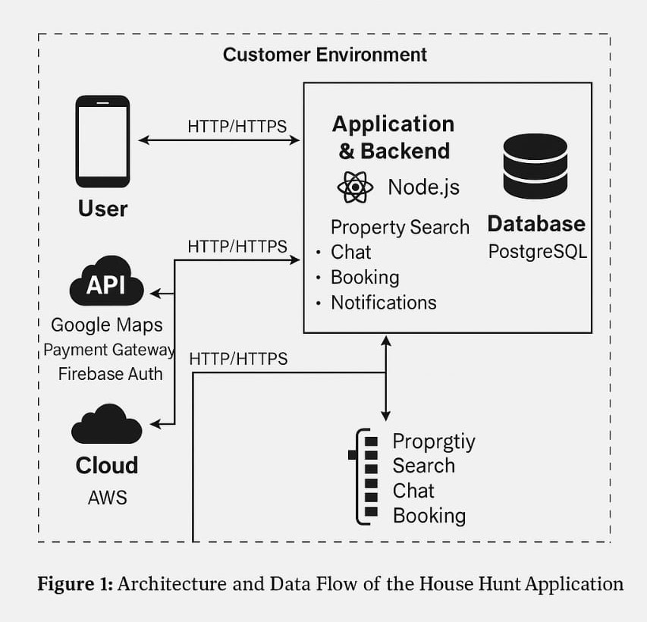

**Figure 1**: Architecture and Data Flow of the HouseHunt Application

**Key Architecture Components:**

|  |  |
| --- | --- |
| **Layer** | **Technologies / Responsibilities** |
| **Frontend** | Built using **React.js**, styled with **Material UI** and **Bootstrap** for responsive design. |
| **Backend** | Developed in **Node.js** with **Express.js**, responsible for APIs, routing, authentication, etc. |
| **Database** | **MongoDB** for storing users, bookings , properties, in structured collections. |
| **Authentication** | **JWT** based secure login for renters, owners, and admins. |
| **Real-time Chat** | Enabled via **Socket.IO** to allow users and agents to communicate on complaint threads. |
| **Email/SMS Alerts** | Uses **Nodemailer** and optionally **Twilio** for notifications and updates. |
| **Hosting** | Frontend and backend can be deployed on **Vercel**, **Render**, or **MongoDB Atlas** (cloud DB). |

**Reference**

**AWS Blog – Voice Applications in Clinical Research (Architecture and Design Considerations)**

[https://aws.amazon.com/blogs/industries/voice-applications-in-clinical-research-powered-](https://aws.amazon.com/blogs/industries/voice-applications-in-clinical-research-powered-by-ai-on-aws-part-1-architecture-and-design-considerations/) [by-ai-on-aws-part-1-architecture-and-design-considerations/](https://aws.amazon.com/blogs/industries/voice-applications-in-clinical-research-powered-by-ai-on-aws-part-1-architecture-and-design-considerations/)